I. STATISTICS

1.1. Complaints received by the Ombudsperson and own-iniatiative investigations
The Ombudsperson for Children:
shall investigate the submitted complaints: | shall carry out an investigation on his own initiative:
concerning the acts (omissions) of persons as a result of which the rights or legitimate interests of children are violated (allegedly violated) or could be violated;  concerning misuse of powers of officials or bureaucracy in the field of the protection of the rights of children. | having information about (possible) violations of the rights of children;  in order to assess the enforcement of the rights of a particular group of children or the rights of a child in a particular area.
@
Send by e-mail
vtaki@vtaki.lt
(scanned document with signature)
Send by mail
Electronically - the document must be signed with electronic signature
deliver to the Office of the Ombudsman
(Plačioji St. 10 Vilnius)
Send a fax
(8 5) 265 7960
A person can submit a complaint in several ways
Requirements for the complaint (exceptions apply):
The complaint must be signed.
At the request of the complainant, his name shall not be published in the further investigation.
Anonymous complaints shall not be investigated, unless the Ombudsperson decides otherwise.
Complaints filed after the expiry of one year after commitment of acts (omissions) shall not be investigated, unless the Ombudsperson decides otherwise.
A child may apply to the Ombudsperson on his own. The requirements of the complaint provided in the law shall not apply to the child.
If the Ombudsperson in another way (form) receives information that the rights or legitimate interests of children could be violated because of the acts (omissions) of certain persons, as well as if it sees a need to assess the enforcement of the rights of a particular group of children in a particular area, the Ombudsperson shall carry out an investigation on his own initiative in order to analyse and answer systemic issues.
CASES INITIATED  516 | IDENTIFIED VIOLATIONS OF CHILDREN‘S RIGHTS  848 |  | CASES COMPLETED  559

CASES INITIATED FOLLOWING COMPLAINT FROM A PERSON | INVESTIGATIONS INITIATED BY THE OMBUDSPERSON
1.2. Complainants
According to Article 16 (1) of the Law on the Ombudsperson for children, a complainant may be a person who applies to the Institution by submitting a complaint that the rights or legitimate interests of children could be violated, as well as the complaint concerning misuse of powers of officials or bureaucracy in the field of the protection of the rights of children.
97 proc.
individual complaints

3 proc.
collective complaints

1.3. Issues related to complaints received
In 2020, a total of 666 complaints of possible violations of children's rights were received.
The most frequent complaint (48%) was about the failure to ensure adequate implementation of the child's right to education, which is undoubtedly related to the challenges caused by the quarantine imposed in Lithuania due to the COVID-19 pandemic and the restriction of children's contact education.
A significant number of complaints (14%) were also lodged in relation to the violation of children's rights and legitimate interests by the acts (omissions) of the territorial units of the Office, i.e., improperly or unjustifiably applied provisions of the legal acts in a specific situation, related to the child and the child's family's well-being. The persistently high number of referrals related to cases of child abuse and neglect (9%) remains a major concern. Problems of the child's communication with the separated parent and close relatives also remain relevant (6%), and the importance of solving these problems and of preserving the child's identity in this respect has become particularly evident during the period of the quarantine, when the restrictions on movement, imposed by the Government of the Republic of Lithuania, have served as the basis for the unjustified denial of the child's access to the separated parent.
Other investigations initiated by the institution is related to various other violations of the rights and legitimate interests of the children. In 2020, investigations were initiated on the basis of complaints received from persons, as well as investigations on the Ombudsperson's initiative concerning the inappropriate application of the provisions on the organisation of guardianship, the possible unlawful removal of a child from his/her family, the inadequate representation of the child's interests in civil proceedings, as well as the violation of the child's right to social support and services, the violations of the child's rights in the criminal proceedings (due to the actions of the officials of the pre-trial investigation, interrogation of juveniles), and the issues related to the child's private life (honour and dignity, personal data etc.), moreover, violations of the rights of the child in the mass media, the use of alcohol, tobacco and other psychoactive substances, and etc.

1.4. Cases completed in 2020
The Ombudsperson carried out 559 investigations into possible violations of the rights of children (investigated 477 of persons complaints; carried out 82 investigations on his own initiative).
559  COMPLETED INVESTIGATIONS, of which: |  | 85%  INVESTIGATIONS INTO PERSONS COMPLAINTS  15%  INVESTIGATIONS ON OMBUDSPERSON OWN INITIATIVE
48 (9%) complaints were refused to be investigated on the grounds referred to Article 21 (1) of the Law on the Ombudsperson for Children (it is appropriate to investigate the complaint in another institution; it does not fall within the Ombudsperson's competence; the circumstances of the complaint have been investigated (are being investigated) in court; the complaint has been submitted repeatedly).
In the reference year, about 1,300 interpelliation (30% more than in 2019) were prepared, i.e., documents and explanations were requested from the relevant institutions and/or persons potentially violating the rights of the children, in order to clarify the circumstances referred to in the complainants' complaints and to assess the validity of the complaints, as well as to investigate the information received by any other means on the potential violation of the rights of the children, to collect the evidence and other data necessary for the Ombudsperson's objective decision.

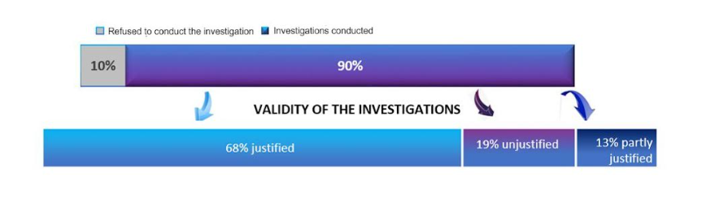

1.5. Investigations completed in 2019 have identified violators of children's rights
In the investigations completed in 2020, 648 acts (omissions) of natural and legal persons were assessed (40% more compared to 2019) in relation to possible violations of the rights of children, 477 (74%) of those persons were found to have violated the rights of the children (in the reference year in 2020 the number of confirmed cases was 23% higher compared to 2019).
People assessed in 2020 investigations
( identified offenders, in percentage)
314  The municipal administration | 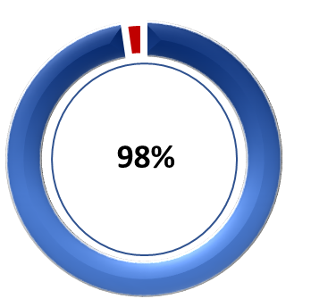 | 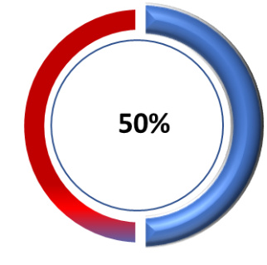 | 18  Guardians (caregivers)  18  Social support centres, etc.
137  Unit for the Protection of the Rights of the Child | 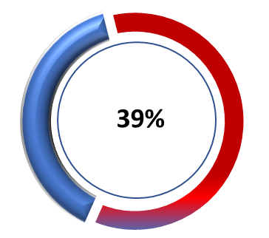 | 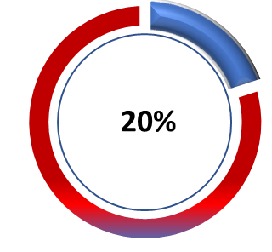 | 5  Public Prosecutor’s Office
61  Family members and relatives | 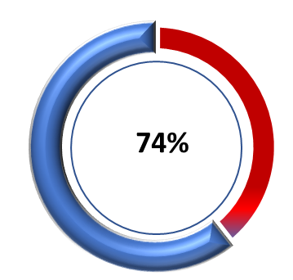 |  | 2  Police
52  Educational establishments | 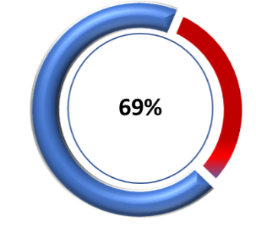 | 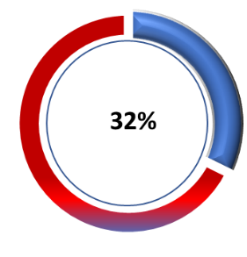 | 34  Other legal persons
As can be seen from the above data, most of cases of violation of the rights of children were reported during the reference year and the highest percentage (98%) of violations were found during the Ombudsperson's investigations of the decisions taken by the municipalities and the resulting negative consequences for the welfare of children (i.e., mostly due to decisions that restricted the opportunities for children to exercise their right to education, which became especially relevant in Lithuania after the announcement of quarantine). As in previous years, the number of complaints about the acts (omissions) of the territorial units of the Office was also high (compared to 2019, the number of violations of children's rights identified in the work of these institutions remained similar, with 39% of the investigations found to be justified or partially justified). The high percentage of confirmed cases of violations of children's rights and legitimate interests is related to the acts (omissions) of their family members (74% of cases were confirmed), the activities of educational establishments and their duty to ensure the proper implementation of children's rights - the right to quality education, a safe educational environment, etc. (69% of cases were confirmed). Although the number of complaints received by the Institution about the inadequate performance of duties by guardians (caregivers) has not been high, the relatively high number of confirmed cases of violations of the rights of children committed by these persons (50%) indicates that issues related to the welfare of foster children are not always properly addressed. It should also be noted that in all cases, complaints alleging violations of the rights of children due to the actions of police officers were confirmed.

1.6. Nature of violations of the rights of children identified in investigations
The investigations completed in 2020 assessed 848 possible cases of violations of the rights of children (30% more compared to 2019).

Failure to ensure a child's right to education is the most frequent violation of the rights of children identified in the reference year. These investigations often found violations of the child's right to be heard, although this was rarely mentioned by complainants. Finally, the violation of the child's right to communicate with the separated parent and close relatives, which occurred much more frequently during the quarantine period (by unjustifiably preventing the child from communicating due to restrictions imposed by decisions of the Government of the Republic of Lithuania), failure to provide proper care for the child and the resulting child-harming behaviour - long-term failure to meet the child's physical and mental needs and the resulting threats to the child's full development and functioning, as well as violence against children - are also among the most frequent violations of children's rights identified by the Ombudsperson's investigations.

1.7. Decisions taken by the Ombudsperson
After investigating the submitted complaint or conducting an investigation on its own initiative, the Ombudsperson shall make a decision indicating the circumstances established during the investigation, the evidence gathered and the legal assessment of the persons' activities.
During the reporting period, the Ombudsperson made a total of 1,772 decisions (3 times more than in 2019), mostly drawing the attention of natural persons and institutions to the violations of the rights of children and, accordingly, proposed measures to prevent their recurrence (42% of the cases). also made other recommendations (28%), the implementation of which would lead to greater welfare of the child.
1
54
37
22
17
297

With the mediation of the Ombudsperson, the problems were resolved in good faith | Activities violating the rights of the child were stopped during the investigation | The circumstances that led to the investigation have disappeared | Lack of objective evidence of an violations | The grounds for not examining a complaint under the law become clear | The complainant requested that the complaint not be investigated
It should be noted that the investigations carried out by the Institution are becoming more complicated, taking into account the complex problems identified in the individuals' complaints, covering a wider range of persons connected with the children and their acts (omissions), which cause a wide range problems in ensuring the rights of children. For this reason, the decisions made by the Ombudsperson are usually focused on several problem areas, and in order to achieve real positive changes, the decisions not only warn the persons or draw their attention to the detected violations, but also provide specific suggestions and recommendations on how to improve the situation of the child in the family, in the educational institution, etc., what specific measures are needed to deal with the situation requiring change.

1.8. Control over the implementation of decisions taken by the Ombudsperson
The Ombudsperson shall make a decision after investigating the circumstances specified in the complaint or conducting an investigation on his own initiative. All natural and legal persons to whom it is addressed must examine this decision and inform the Ombudsperson about the results of the examination and the execution of the decision.
Depending on the nature of the established violation of the rights of children and other circumstances, in order to ensure the effective and efficient protection of the rights and legitimate interests of children, the enforcement of the decision may be controled either temporary (until a specific enforcement date or performance of action ) or periodically (indicating the periodicity of providing information to the Ombudsperson).
In the reference year, 90% of the enforceable decisions were implemented, despite the recommendatory nature of the Ombudsperson's decisions, which shows that there is trust and confidence in the effectiveness of the Ombudsperson's suggestions, recommendations and proposed measures to address issues related to the protection of the rights of children. At the same time, it should be noted that, taking into account the fact that the Ombudsperson's investigations become more complicated each year and, consequently, the Ombudsperson's decisions often raise the need for complex measures and systemic changes, some of the Ombudsperson's decisions have been delayed or have a target date of 2021 (the target date does not coincide with the reference year).

1.9. Examination and consultation of complaints of persons
Anyone, including the children, can contact the Office of the Ombudsperson for Children in case of any issues related to implementation of the rights and legitimate interests of children, protection, etc., as well as in case of a (possible) violation of the rights of children.
Oral or written requests from complainants which do not complain about the acts (omissions) of natural or legal persons, but ask for clarification, information or requested documents, etc., shall not be considered complaints.
Written complaints from persons
Consultations at the institution
Written consultations
Telephone consultations
5%
2%
35%
58%

It should be noted that some of the complainants (5 cases) did not provide their personal data when submitting a complaint to the Ombudsman (the complaints were investigated on an anonymous basis) and were therefore not included in the statistics on complainants provided.

